Day 3: SWITCH AND ROUTER CONFIGURATION THEORY
- Log in to Cisco Packet Tracer or any network simulation tool, add a switch, and create two VLANs named 'Sales' and 'Support' with VLAN IDs 10 and 20.
ANSWER
You can create this in Cisco Packet Tracer using the following steps:
Create VLANs 10 and 20
- Open Cisco Packet Tracer.
- Add a 2960 switch to the workspace.
- Click the switch and open the CLI tab.
- Enter these commands:
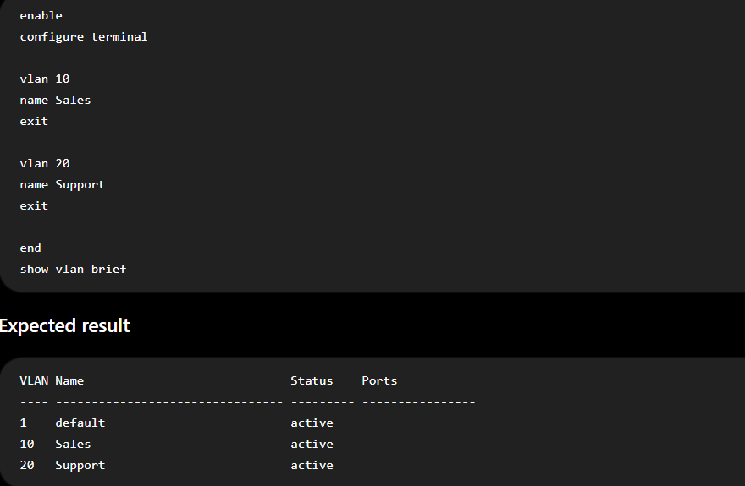
Conclusion: VLAN 10 (Sales) and VLAN 20 (Support) have been successfully created on the switch. The show vlan brief command verifies that both VLANs exist.

- Assign three different switch ports to VLAN 10 (Sales) and two ports to VLAN 20 (Support), then verify the VLAN membership using the show vlan command. Use the interface range command to select multiple ports efficiently.
Answer
Use the following Cisco Packet Tracer commands on your switch. Assuming Fa0/1–Fa0/3 are for Sales and Fa0/4–Fa0/5 are for Support:
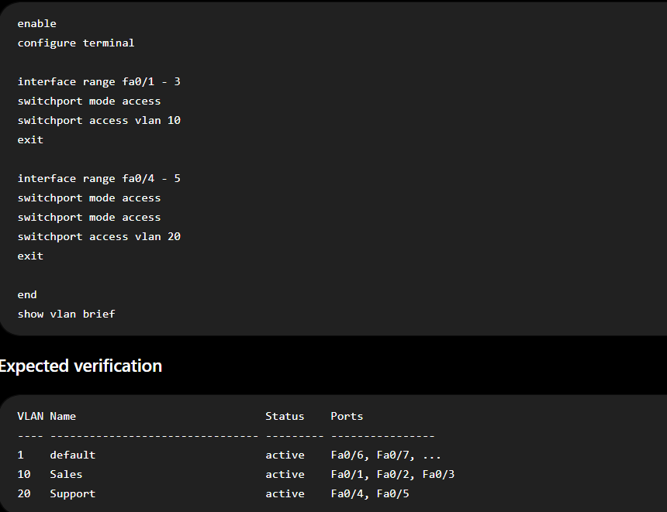
Result
VLAN | Name | Assigned Ports
10 | Sales | Fa0/1, Fa0/2, Fa0/3
20 | Support | Fa0/4, Fa0/5
The show vlan brief command verifies that three ports belong to Sales (VLAN 10) and two ports belong to Support (VLAN 20).

- Connect two routers using a serial or Ethernet link in your simulation tool, assign IP addresses to their interfaces, and configure a static route on Router 1 to reach the LAN behind Router 2.
Answer
1.Configure Router 1 Interface:Inter-Router Link Setup.
Assign an IP address to the interface connecting Router 1 to Router 2 (using GigabitEthernet 0/0/0 as an example) and bring the interface up:
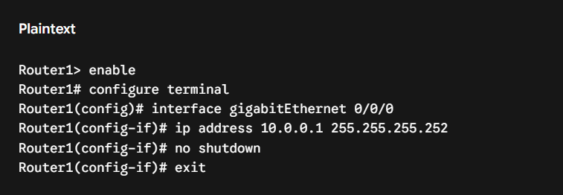
2.Configure Router 2 Interfaces:Inter-Router & LAN Setup.
Configure the connecting interface to Router 1 along with the LAN interface behind Router 2 (e.g., 192.168.2.0/24):
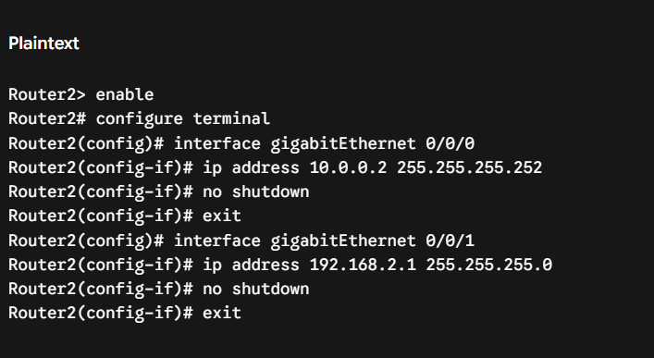
3.Configure Static Route on Router 1:Static Route Command.
Define a static route on Router 1 target pointing to Router 2's LAN network (192.168.2.0/24) using Router 2's IP (10.0.0.2) as the next hop:
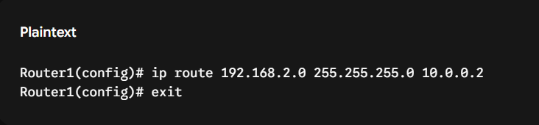
4.Verify the Routing Table and Connectivity:Verification.
Check the routing table on Router 1 and test reachability via ping:
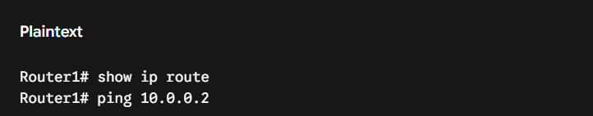
Verification Check: Confirm 192.168.2.0/24 is listed in the routing table with code S (Static) and that the ping returns a 100% success rate.
- Simulate a scenario where a device in the 'Sales' VLAN tries to ping a device in the 'Support' VLAN and explain why the ping fails, then suggest what configuration would allow inter-VLAN communication. Think about router-on-a-stick or Layer 3 switch concepts.
Answer
1.Execute the Ping Test between VLANs:Simulation & Test.
- Assign a device in VLAN 10 (Sales) the IP address 192.168.10.10 /24.
- Assign a device in VLAN 20 (Support) the IP address 192.168.20.10 /24.
- Open the command prompt on the VLAN 10 device and initiate a ping to the VLAN 20 device:

Result: The ping fails with a Request timed out error.
2.Understand Why Inter-VLAN Traffic Fails:Root Cause Analysis.
- Layer 2 Isolation: Switches operate at Layer 2 and treat each VLAN as an entirely separate broadcast domain and logical network subnet.
- No Route: Because VLAN 10 (192.168.10.0/24) and VLAN 20 (192.168.20.0/24) belong to different IP subnets, traffic cannot pass between them without a Layer 3 routing device to route packets between the subnets.
3.Implement Inter-VLAN Routing Solutions:Solution Options.
To allow communication between the two VLANs, configure one of two standard approaches:
- Option 1: Router-on-a-Stick (RoAS)
  - Connect the switch to a router port via an 802.1Q trunk link.
  - Configure sub-interfaces on the router (e.g., g0/0/0.10 and g0/0/0.20), assigning each the default gateway IP address for its respective VLAN subnet.
- Option 2: Layer 3 Switch (SVI)
  - Create Switch Virtual Interfaces (SVIs) directly on a Layer 3 switch (interface vlan 10 and interface vlan 20).
  - Assign the gateway IP address to each SVI and enable IP routing globally using the ip routing command.

